MWERA MIRACLE CENTER

DECEMBER REPORT 2014

COMPILED BY: PASTOR DAVIS DOLLAR .S

CONTACT:
PASTOR SSENDIKWANAWA DAVIS DOLLAR
MWERA MIRACLE CENTER
P.O BOX 1680 KAMPALA, UGANDA EAST AFRICA
davislove123@gmail.com /
+256752896993
ww.mweramiraclecentre.yolasite.com

Introduction

Mwera Miracle Center is a Ministry under the care of the Father, Son, Holy Spirit and Pastor Ssendikwanawa Davis Dollar, After seeing the great need to help the needy children in the area of Kiwande, a Mityana District village, found in Uganda (East Africa), and nearing area around us, this of Kings Miracle Kids Home was started , with the vision to help 100 children and 100 Elders, in our area, now we have 40 children and 100 Elders in our care as the resources are still low, though the need for helping more children is high, these are some of needs we help the children with as God provides Food, clothes, shoes, mattresses, blankets, Bibles, school fees, education necessities, health needs like pads, and Most of all carter for their Spiritual growth and others. Since we started it, we have seen the hand of GOD move with us and thank Jesus for your partnership.
In the Month of 2 November / 2014 our friends from the ACCA ( Auglaize Council on the Aging) helped our elders here with paraffin for their lamps which can take them for three weeks of lighting, soap which can take them a week of washing and keeping clean with their clothes, Sugar for their black tea, Maize flour, salt, matchboxes, We really thank you sister Roby, and the ACCA, and all the team that worked tirelessly to see this event a success in Jesus name, it has covered a great deal for seniors here, as 100 seniors got, basic necessities above, this was greatly welcomed and appreciated.
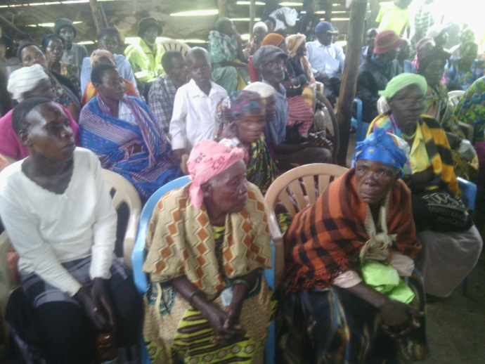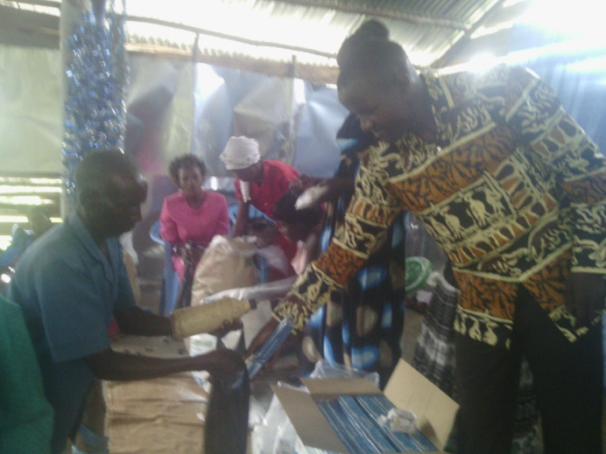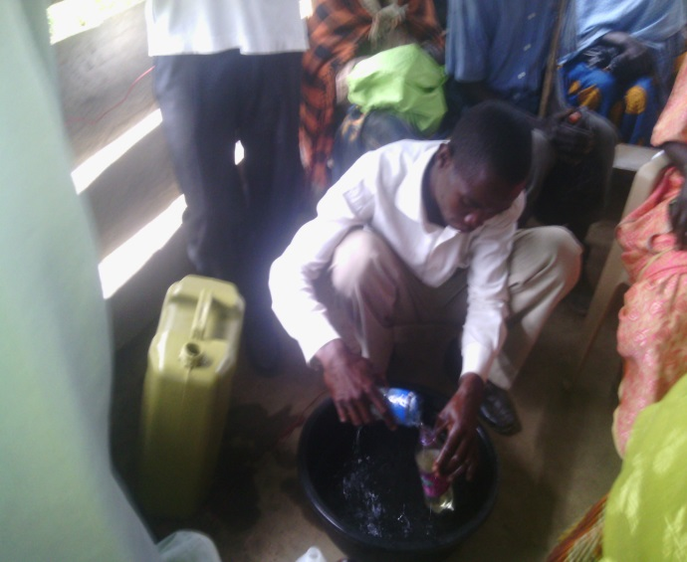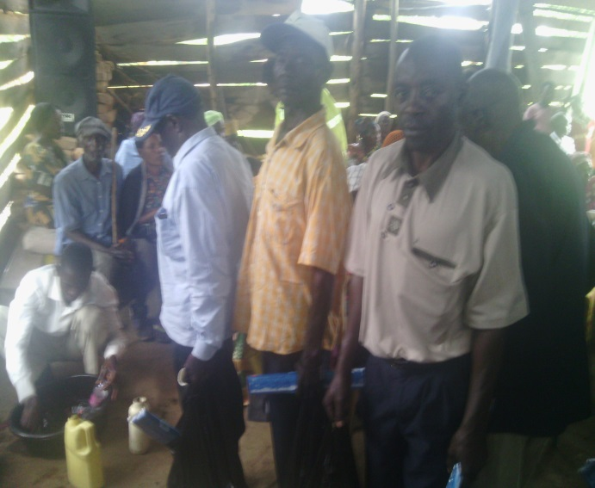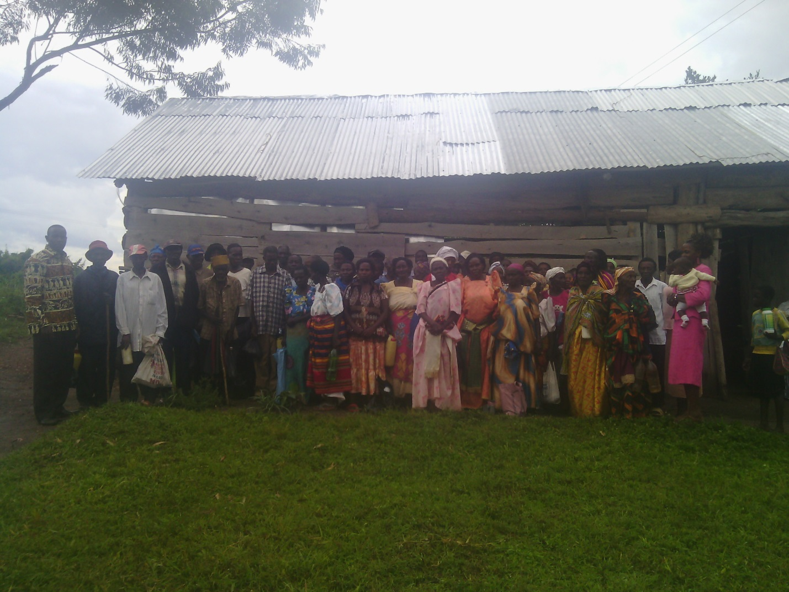
On up Left Elders were waiting for necessities of life, on right Pastor Davis Dollar hands over soap to one of elders as others wait their turn, he showing the heart of service of Christ, on down left a minister measures a litre of parrafine for and elders as others on below right wait their turn to receive too this was a real blessing
In the Month Of December 24/2014 we got another blessing of clothes, food, soap and sweets for the kids, and elders, we organised a christmas party and fed them with, a christmas meal to 130 people of thse there were 70 kids feed, and 60 Elders or Senior it was blast christmas for them as you see in the photos below.
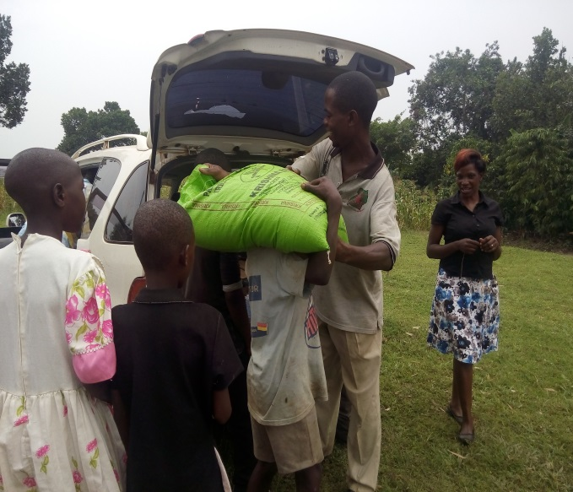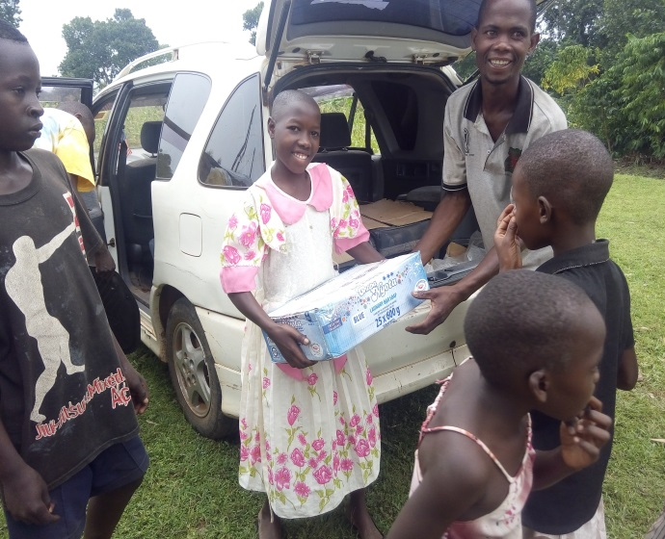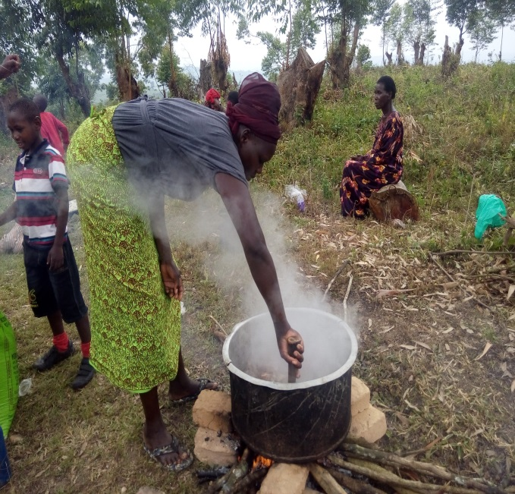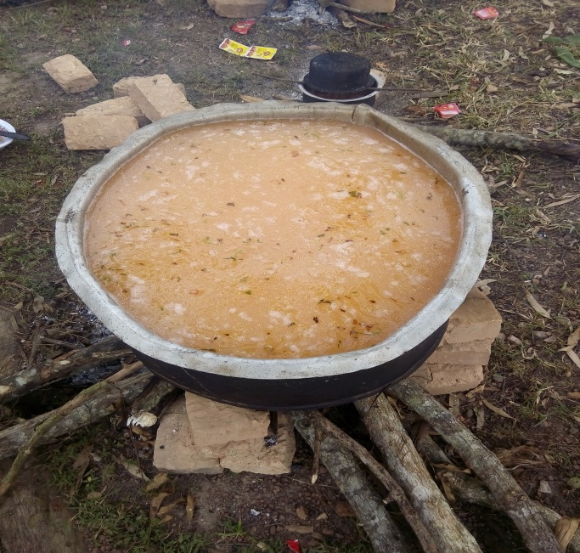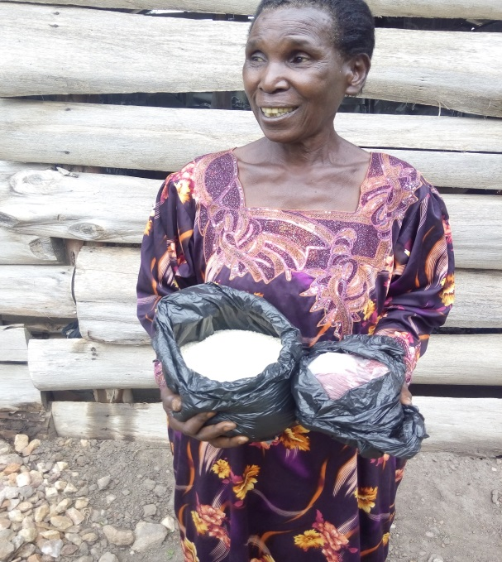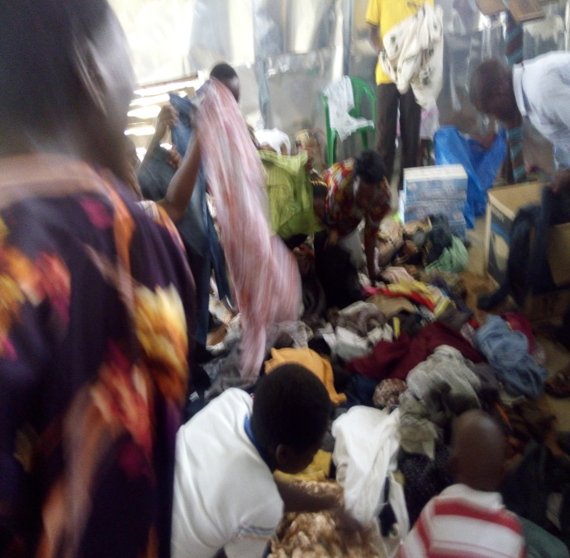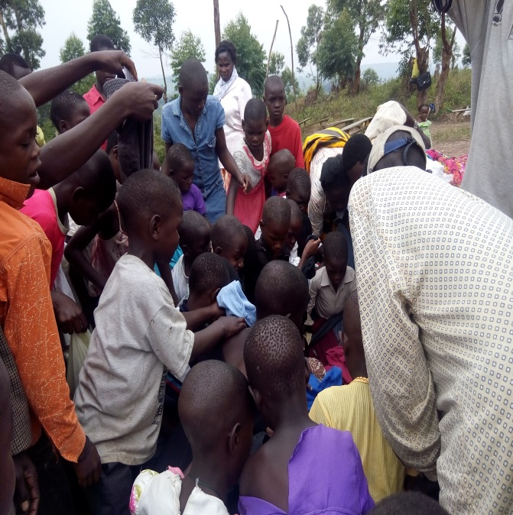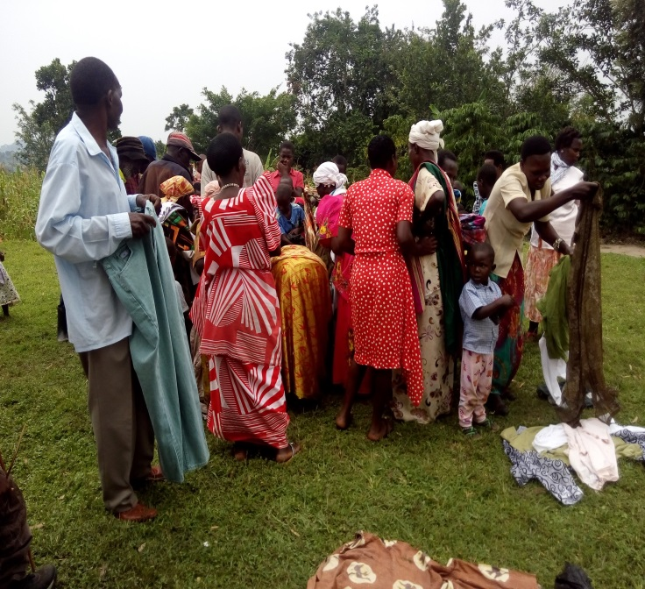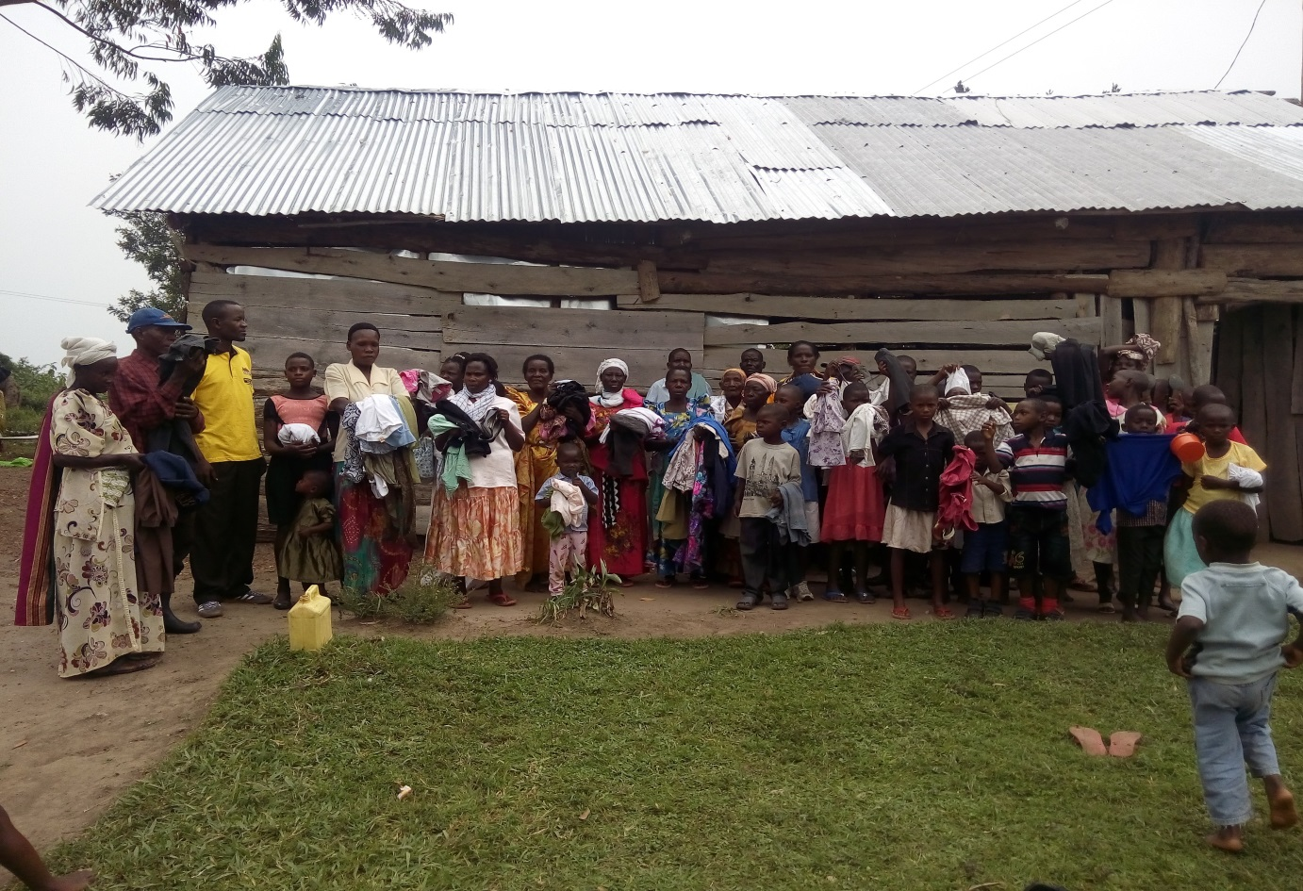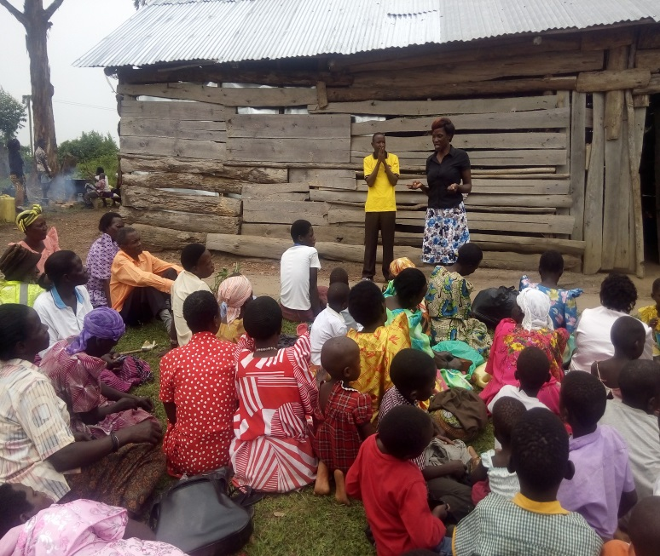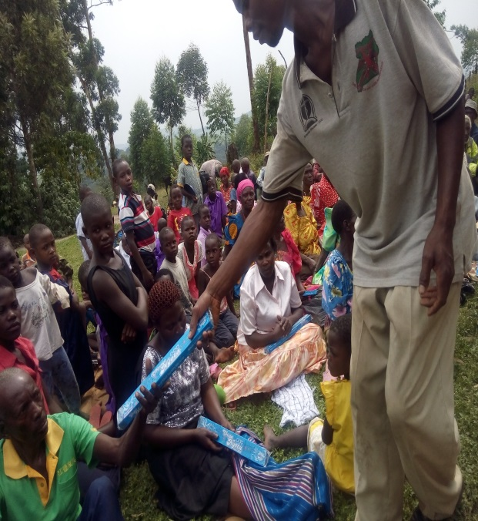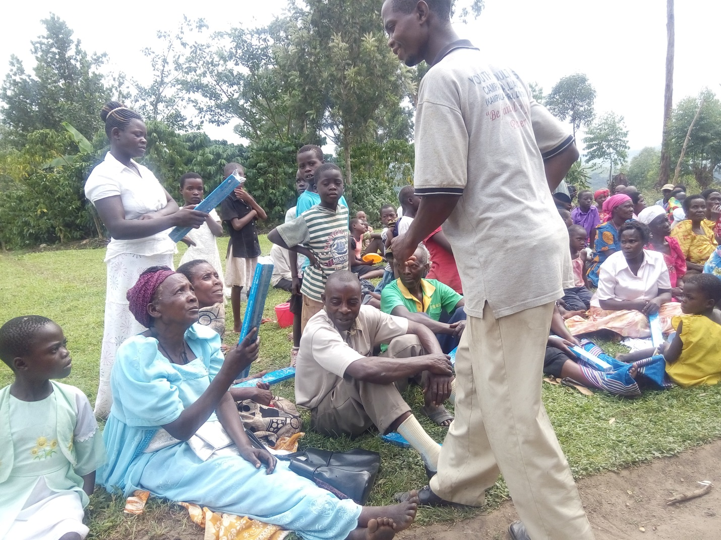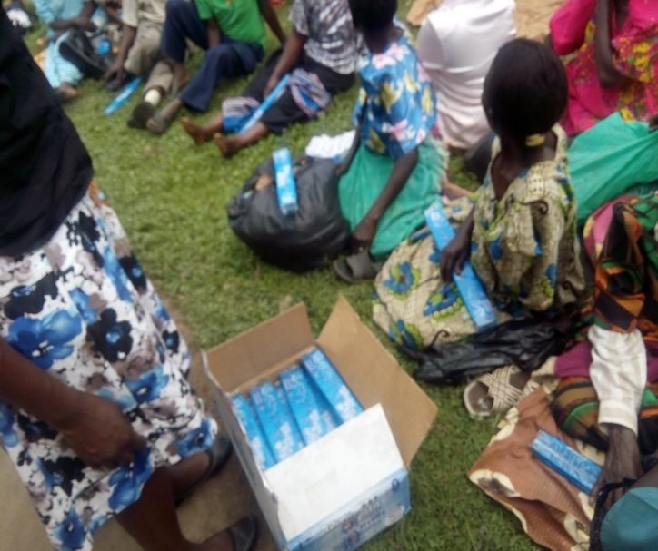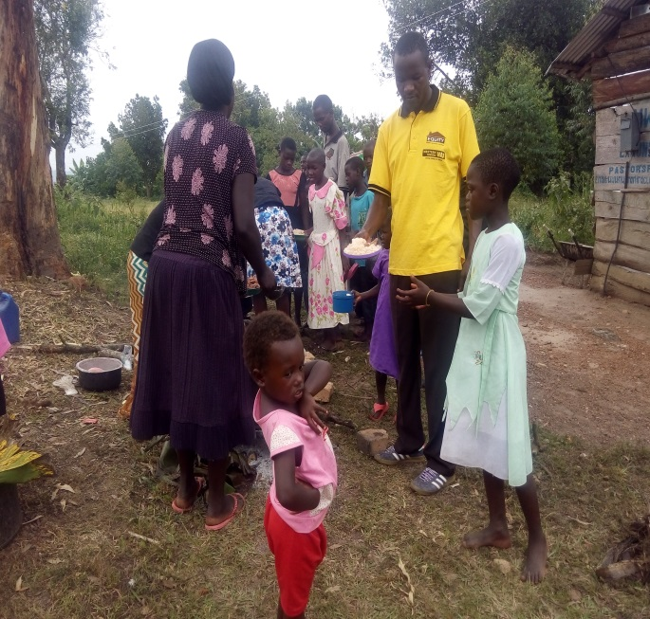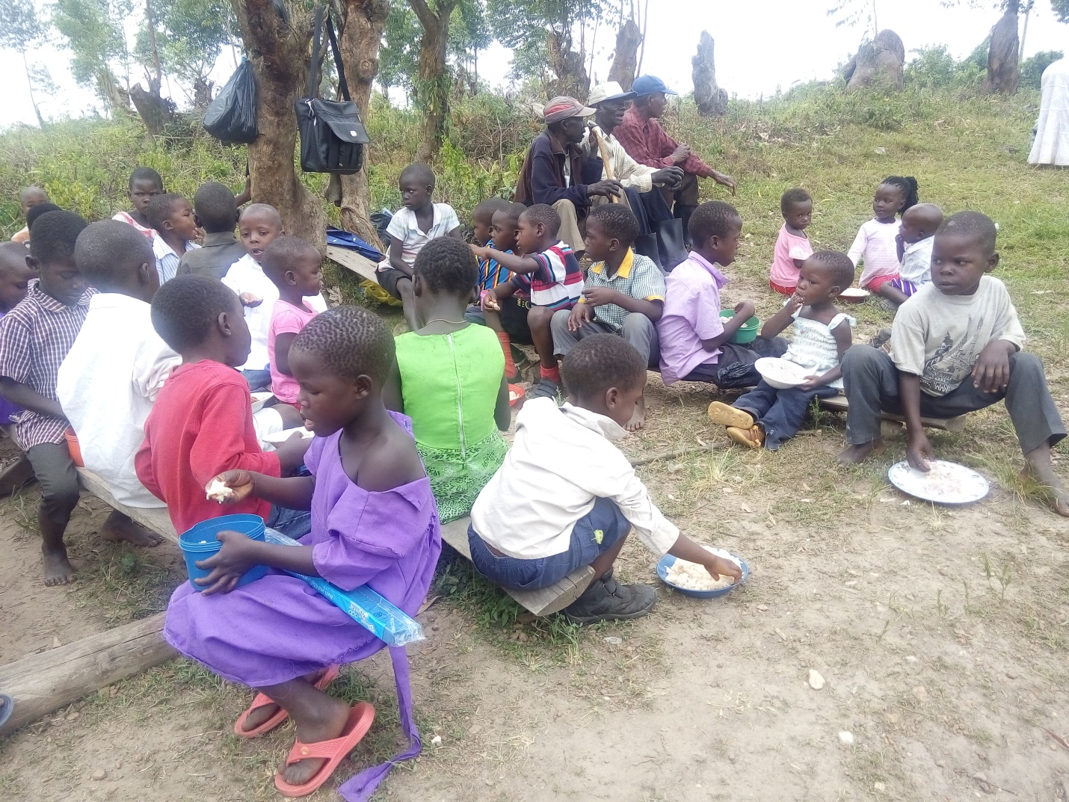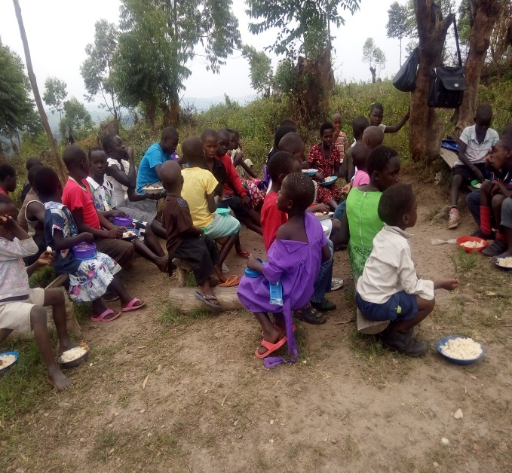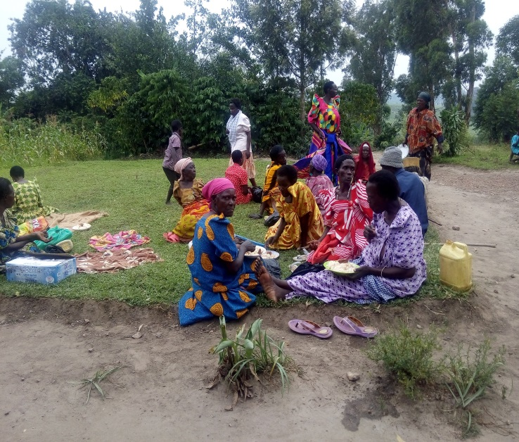
On left and right up things were being unloaded from a hired car on site at church, even kids themselves were involved because of excitement, On left and right below the mingling started for meat and rice, yum yummy
Above an Elder received 3 kilos of meat and rice new dress and shoes, below kids fight for clothes, on left below an Elder gets his lot of clothes too as others pick their, below is the group photo of all Elder and kids who got things on that day of 24
On left the Pastor’s wife speaks to the congregation that gathered for the Christmas party as pastor Davis Watches on, on right and below soap was being given to Elders each showing their catch
Above soap is ready for distribution, on right above Pastor Dollar in yellow t-shirt hand over a plate of food to a needy children for her to have a Christmas meal on the Lord’s day, below on the right Children enjoy a meal on this day look at the dinning these kids have, one girl in purple dress down ate with her soap in hand not loosing it an inch this shows you how of value it was to her, help more by your seed
Elders too enjoying a meal, no dinning yet but believing God for a clean place where meals can be served in the new Children home facility we believe God to build soon, look at the kids and elders putting plates of food down in grass, but at least to get a meal.
In the Month on November we also managed to start of the Office construction which will house, Clinic from where to treat kids and elders for free, a radio station, administration office, project office etc, this how ever is not yet done as the seed we got from a friend did some work and stopped in middle of building we still need more funds to finish it up in Jesus as you see in the pictures below, but we thank Jesus for the work so far done.
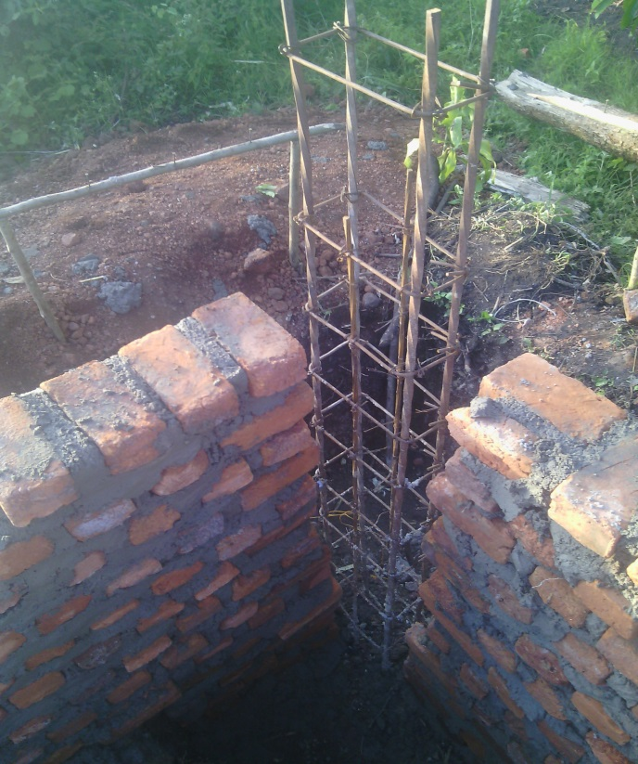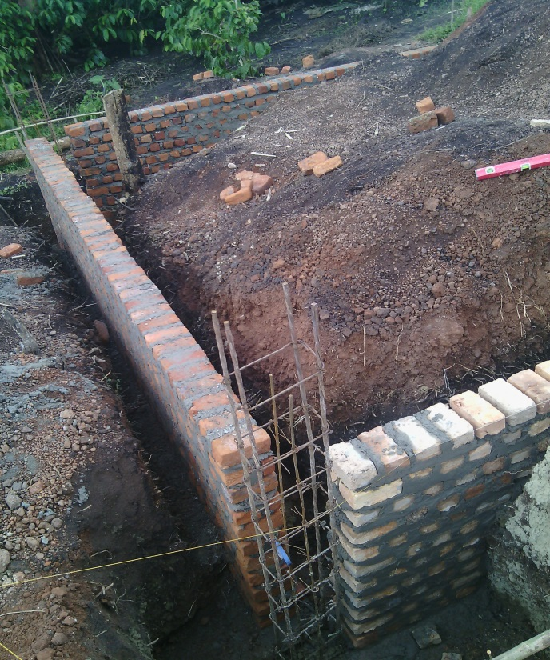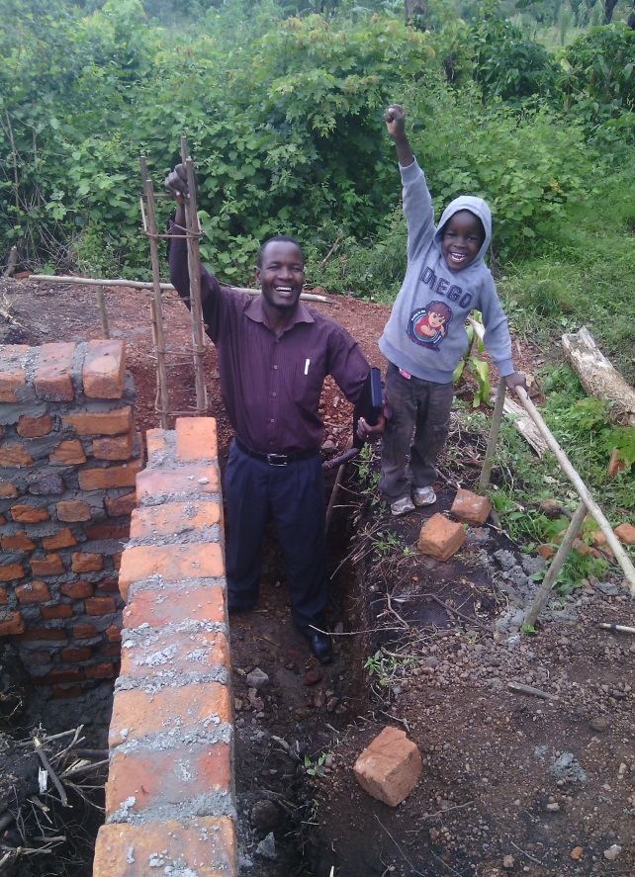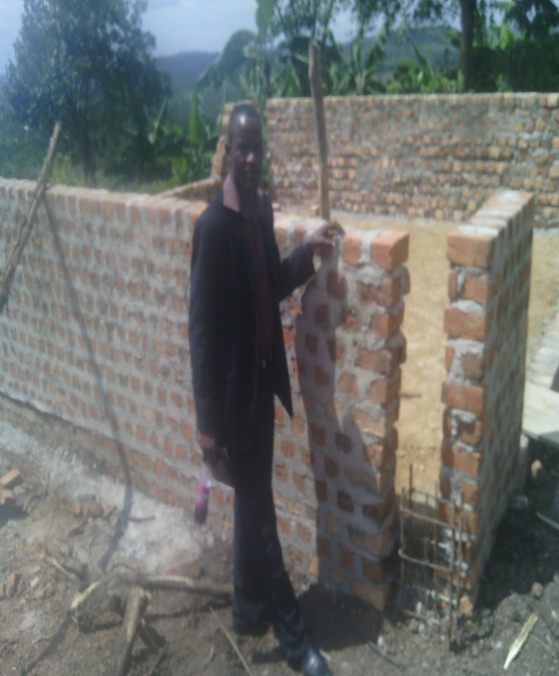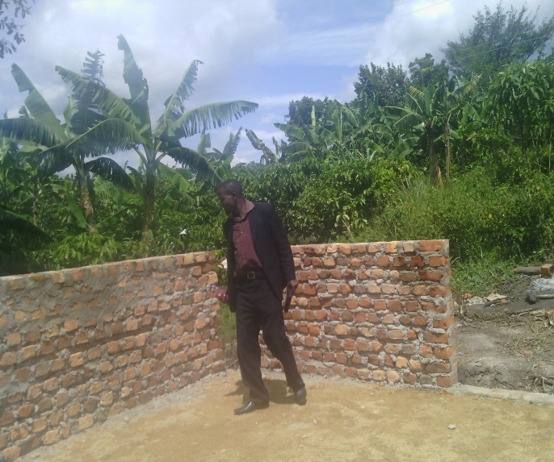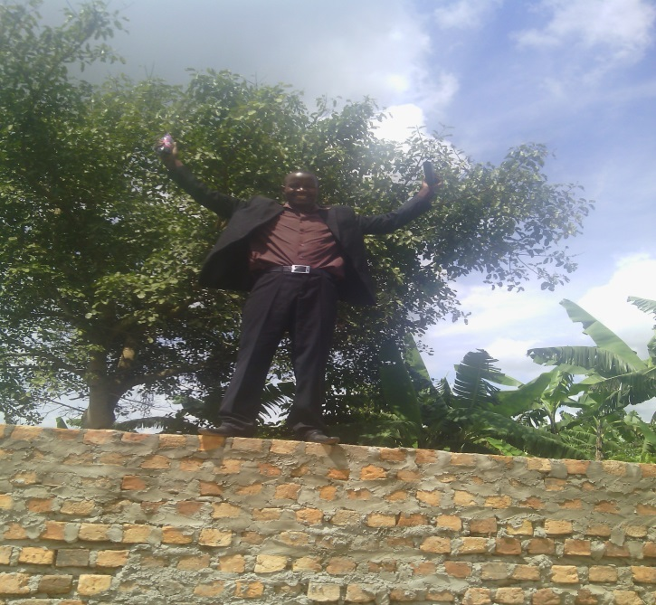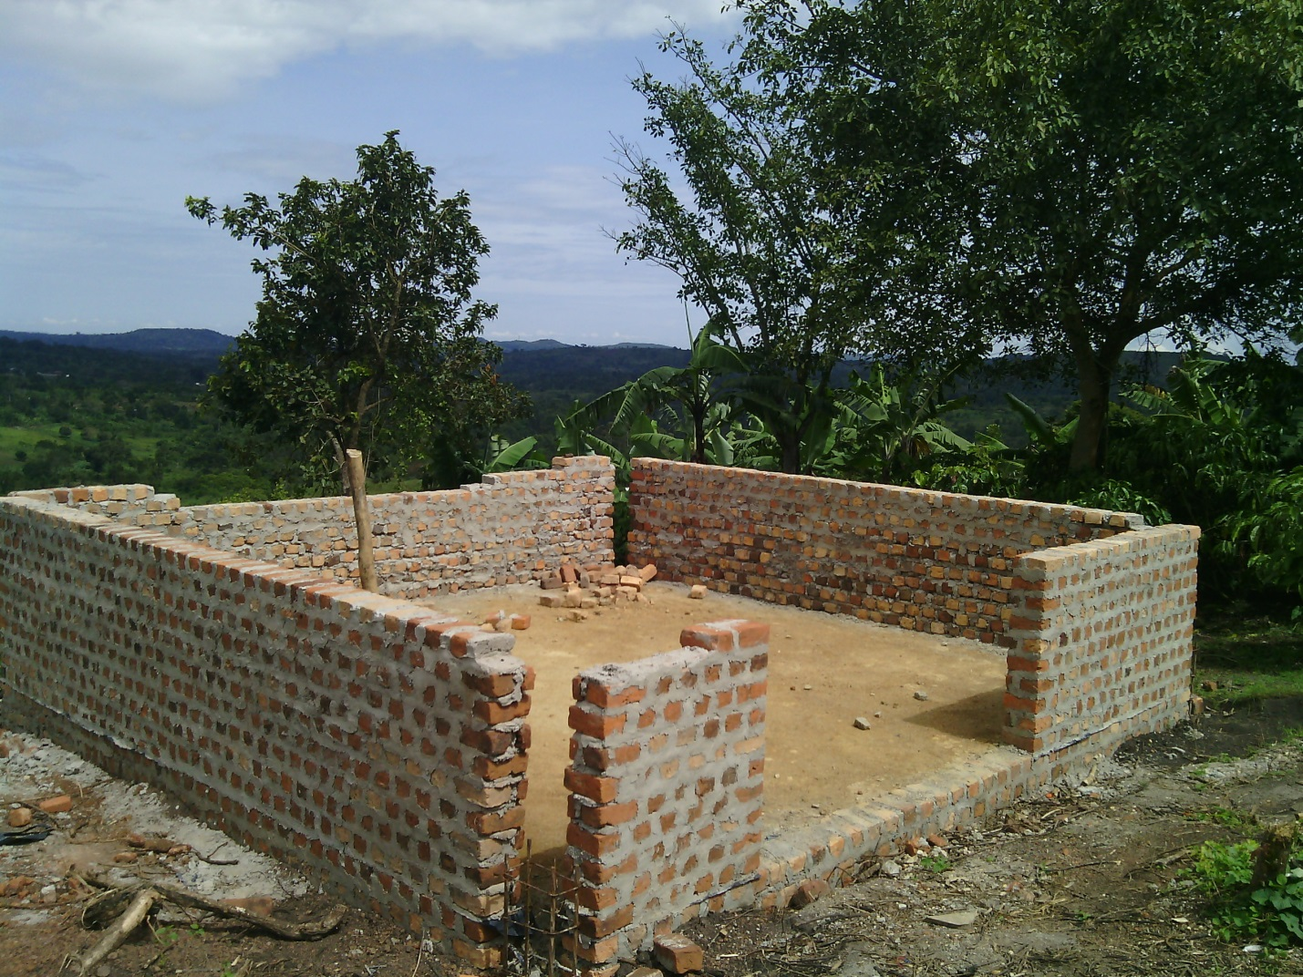
On left and right above is the first stages of the Work being done, see how deep the building started in the ground all that was buried in soil so that the building could manage to carry the three floor coming up.
On left and right is Pastor Davis Dollar with his son inspecting the work done and releasing the joy of the Lord for what being accomplished.
Pastor Ssendikwanawa Davis Dollar Inspecting the work being done and below the accomplishments

All in all we thank God for what has been done so far and accomplished and we thank Jesus for his love to us, and still pray that he that started a good work in us will bring it to accomplishement, and thank all my partners and friends for helping us this far and pray for you that “ MY GOD SHALL SUPPLY ALL YOU NEEDS ACCORDING TO HIS HEAVENLY RICHES IN GLORY IN CHRIST JESUS”
We are believing God to accomplish too the vision of
- A Miracle Children Home
- A new Church structure to sit 3000 people as we believe Jesus to save more community people.
- A Miracle School for the needy kids who cant manage school fees.
- A Teens Center
- A Radio Station
- Farm land of five acres to grow food for the kids feeding
- And a sound system for the ministry
PASTOR SSENDIKWANAWA DAVIS DOLLAR
MWERA MIRACLE CENTER
P.O BOX 1680 KAMPALA, UGANDA EAST AFRICA
davislove123@gmail.com /
+256752896993
ww.mweramiraclecentre.yolasite.com
Blessings.

