MWERA MIRACLE CENTER

EASTER REPORT

COMPILED BY: PASTOR DAVIS DOLLAR .S
APRIL 2014

CONTACT:
PASTOR SSENDIKWANAWA DAVIS DOLLAR
MWERA MIRACLE CENTER
P.O BOX 1680 KAMPALA, UGANDA EAST AFRICA
davislove123@gmail.com /
www.facebook.com/Mircalechildhopepeoject
+256752896993
ww.mweramiraclecentre.yolasite.com

Introduction

I would like first of all to thank all you my friend for making this happen in Jesus name, the Easter Celebration we have done here on 22/4/2014, is under the MIRACLE CHILD HOPE PROJECT (MICHOP), is a project formed out of Mwera Miracle Center ,under the care of the Father, Son, Holy Spirit and Pastor Ssendikwanawa Davis Dollar, After seeing the great need to help the needy children in the area of Kiwande, a Mityana District village, found in Uganda (East Africa), and nearing area around us, this project was started in 2011, with the vision to help 100 children in our area, now we have 40 children in our care as the resources are still low, though the need for helping more children is high, these are some of needs we help the children with as God provides clothes, shoes, mattresses, blankets, Bibles, school fees, education necessities, health needs like pads, and Most of all carter for their Spiritual growth and others. Since we started it, we have seen the hand of GOD move with us and thank Jesus for your partnership.
In this Easter celebration we managed to give out food to 100 people, that; half a kilo of rice and half a kilo of maize flour, and some beans, a half kilo of rice and flour feeds 4 people in a family this means that we gave out 400 plates of food for that day on Easter Alone.
Below are some photos for what took place.
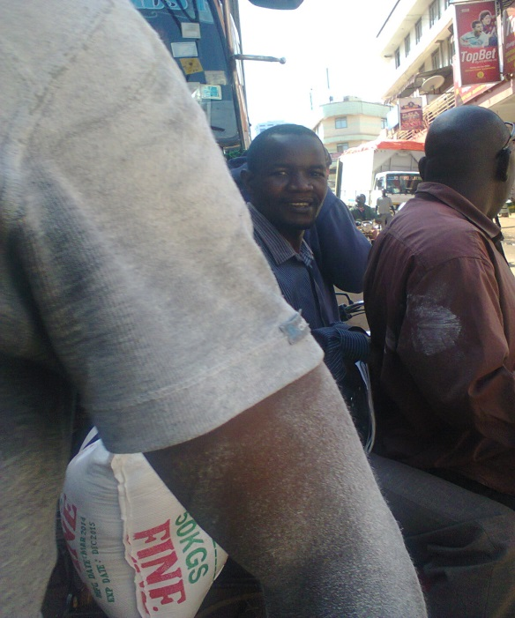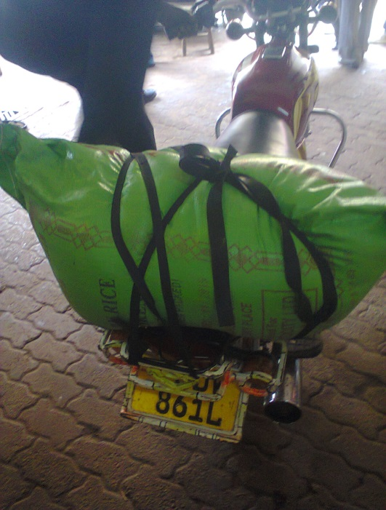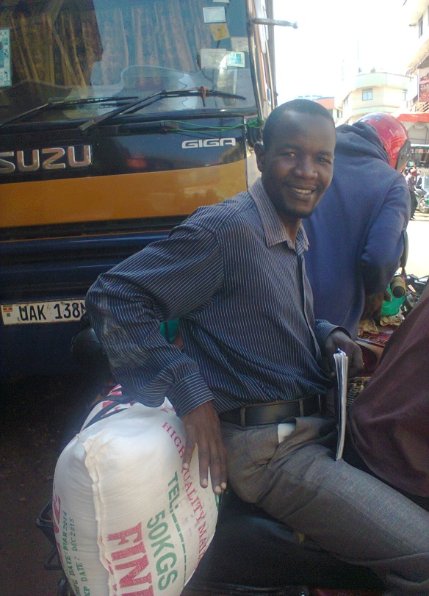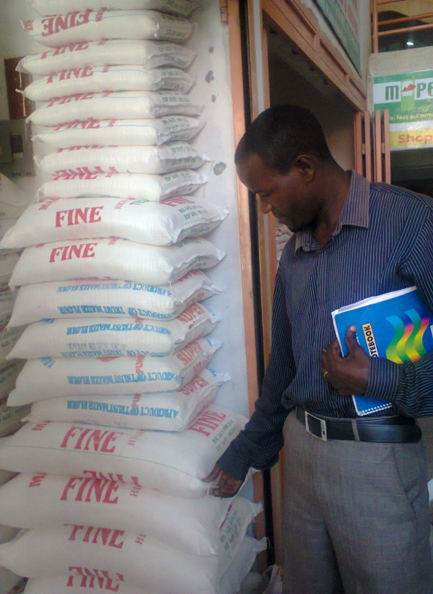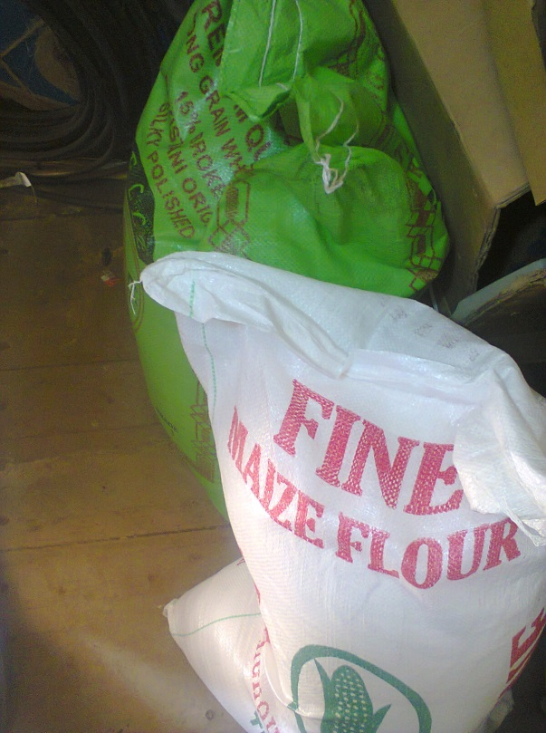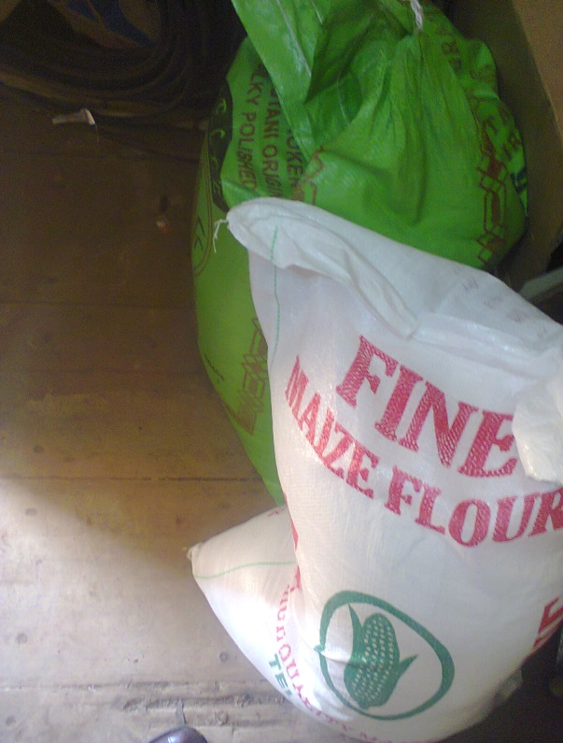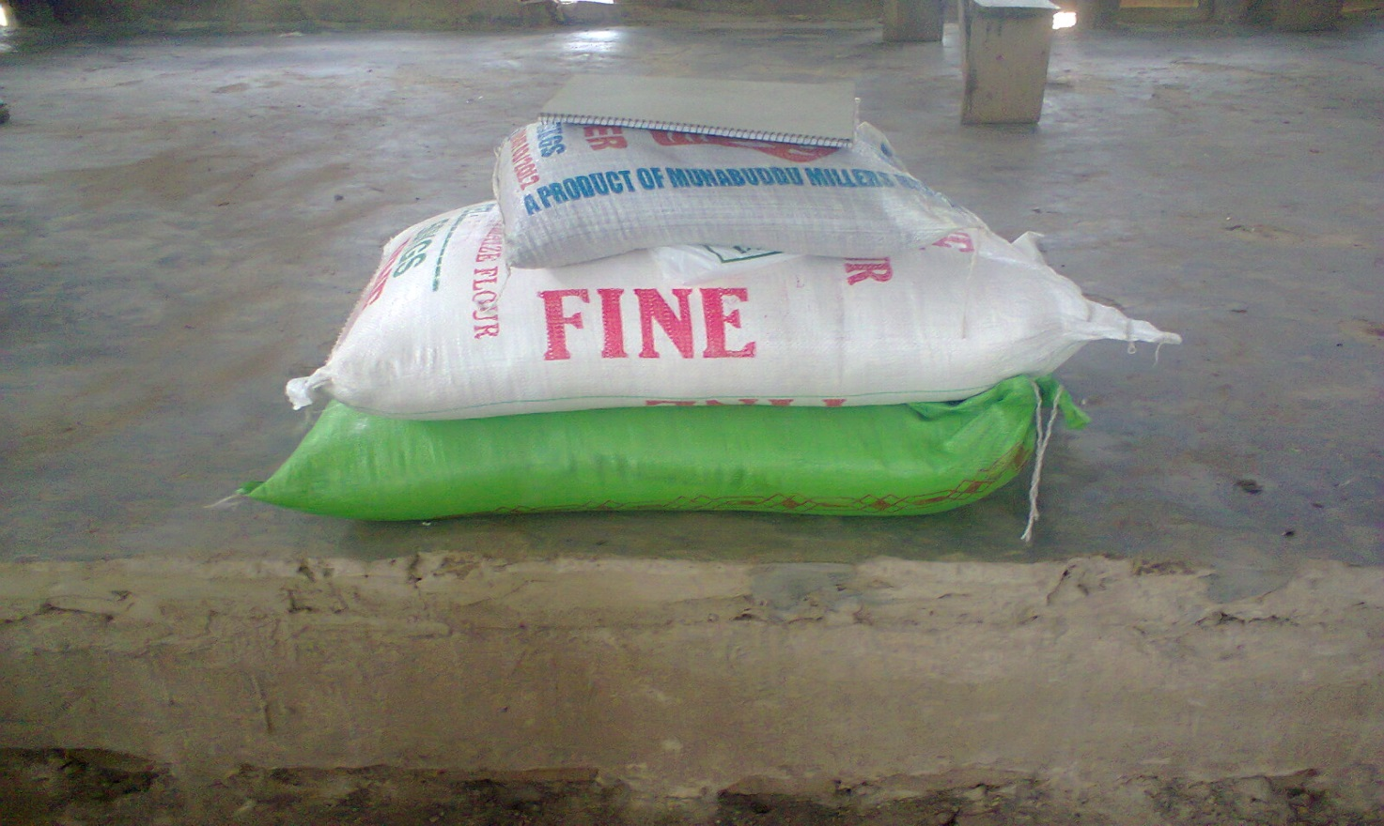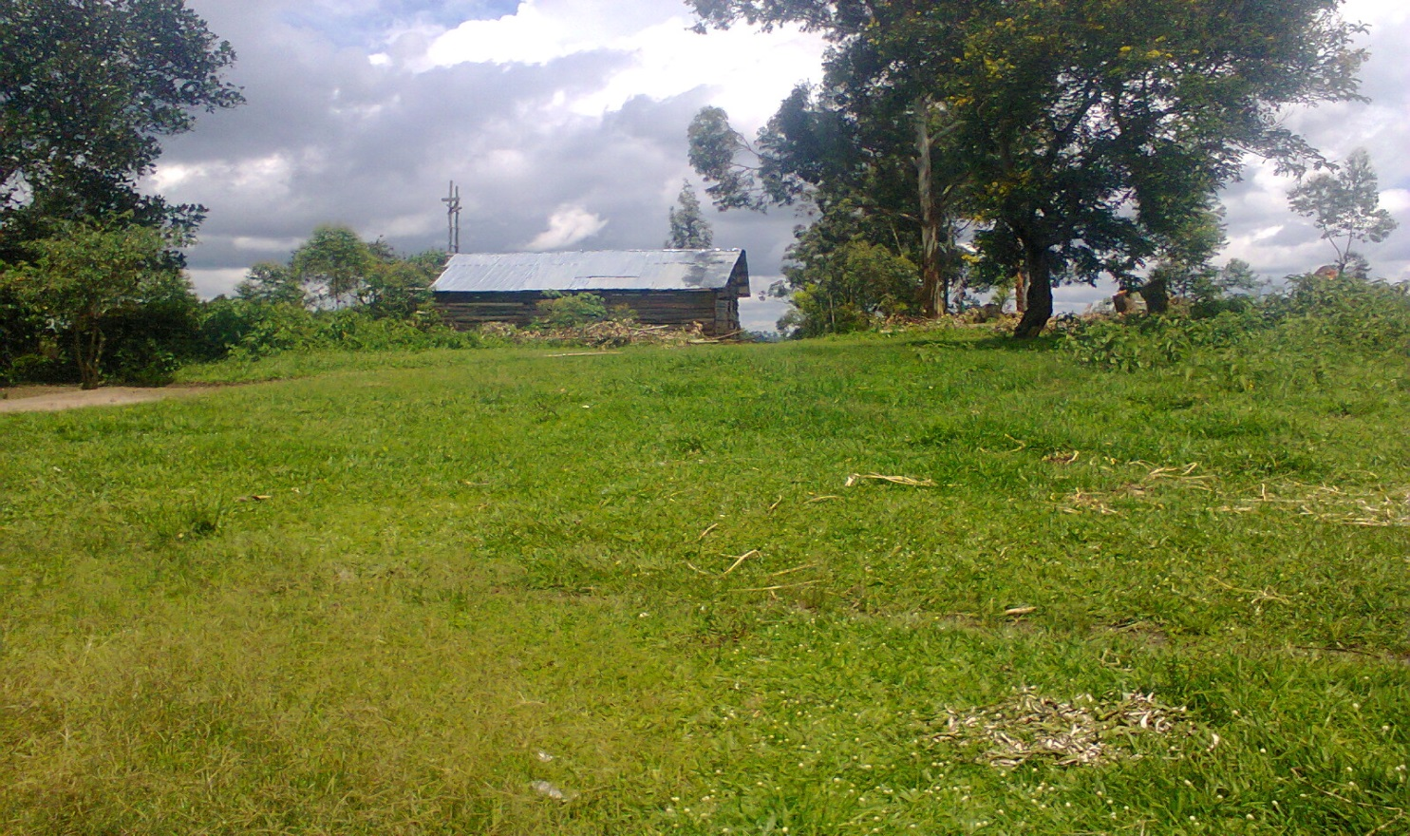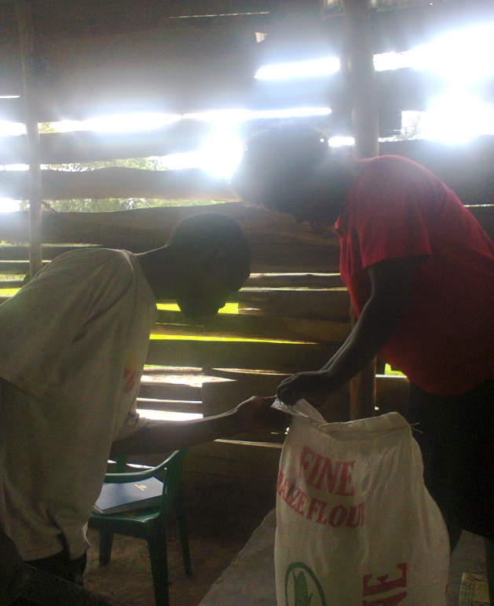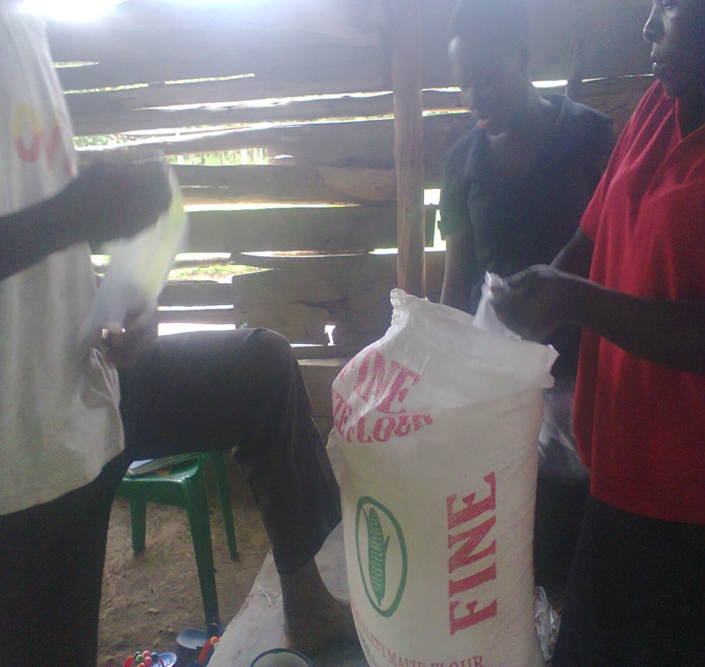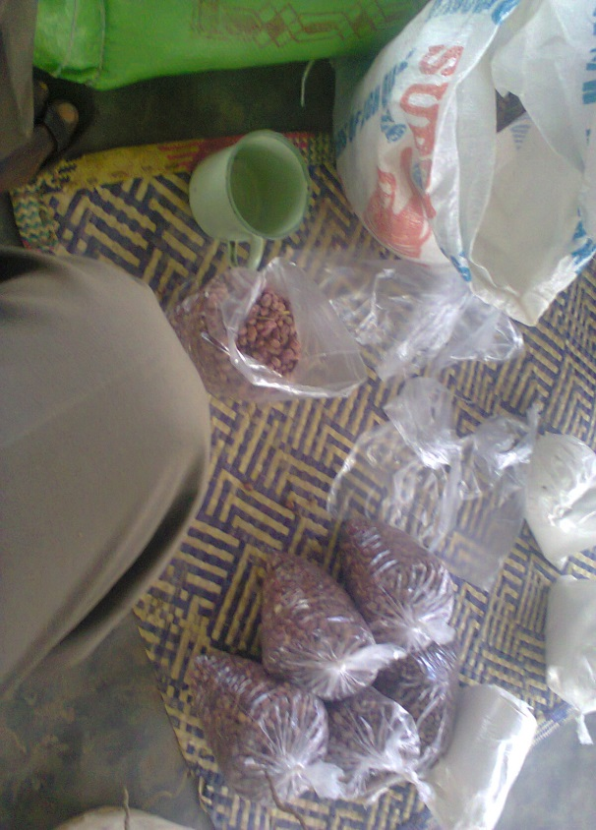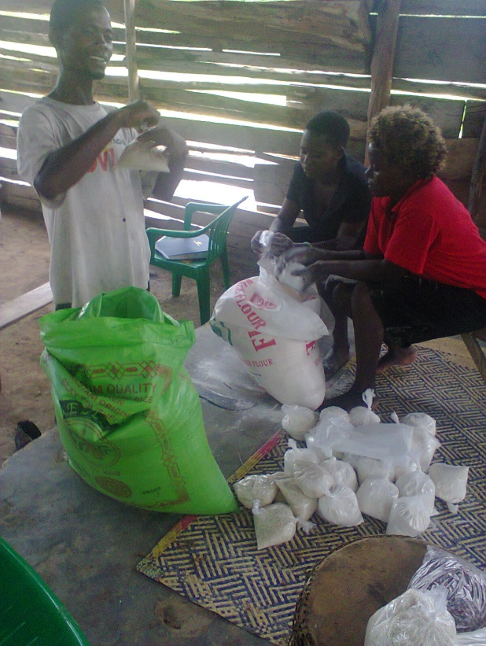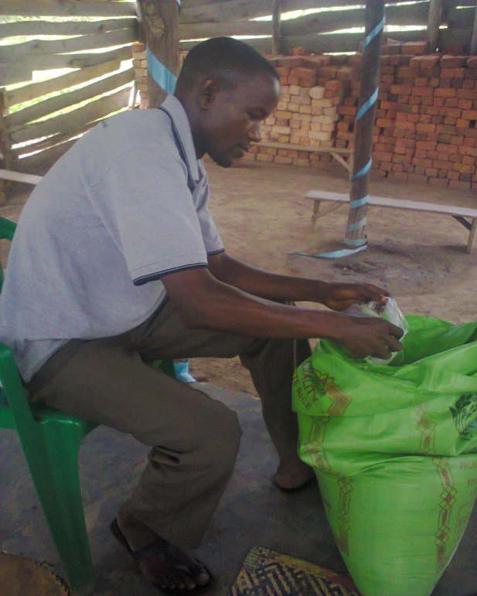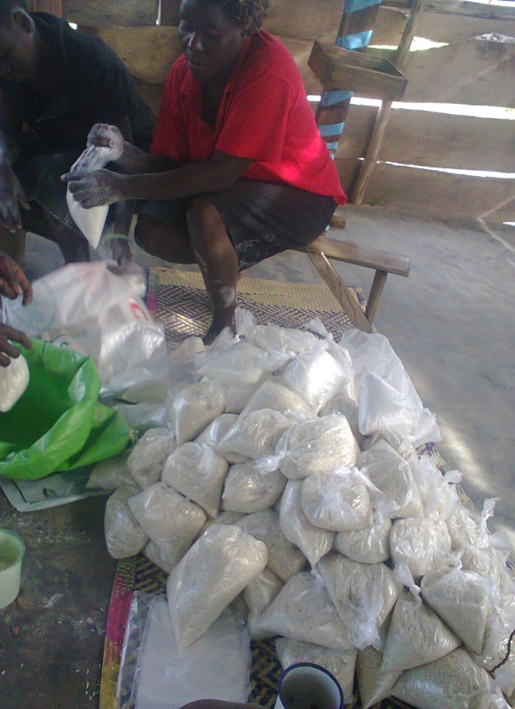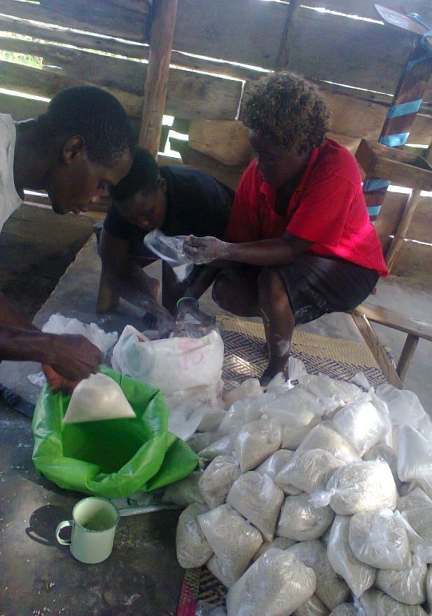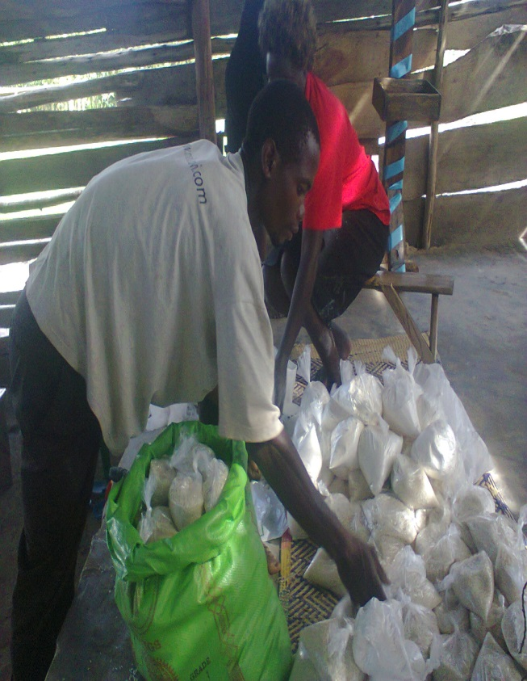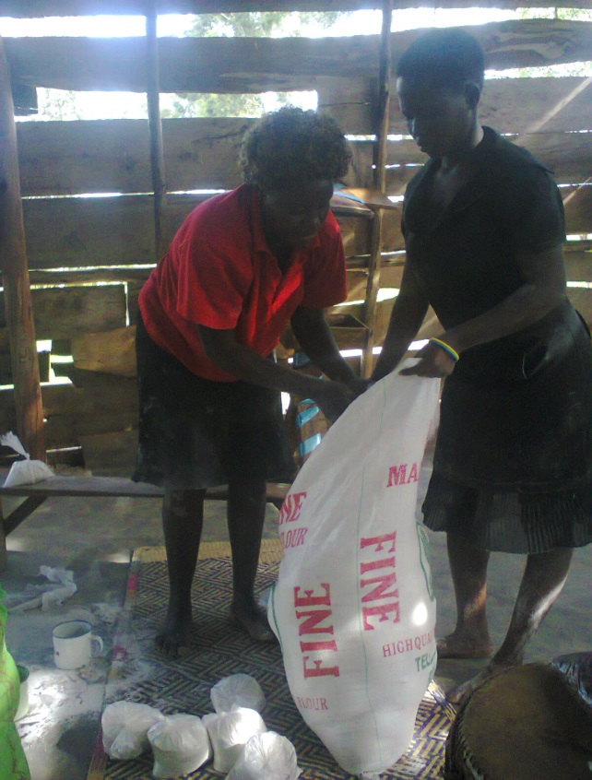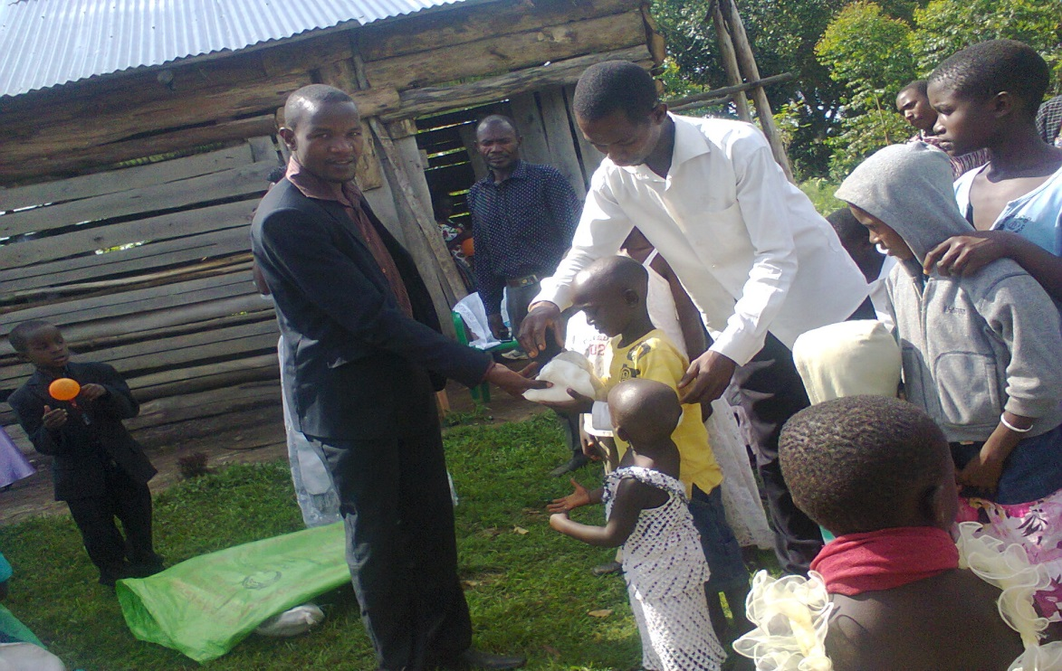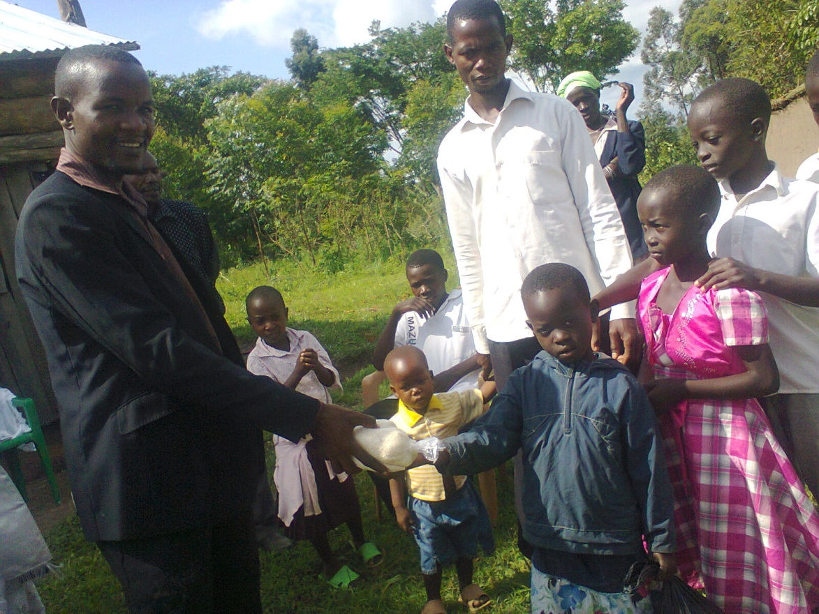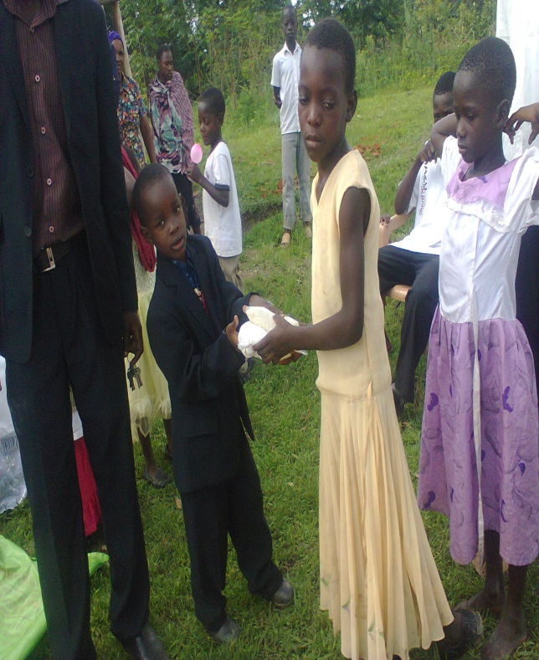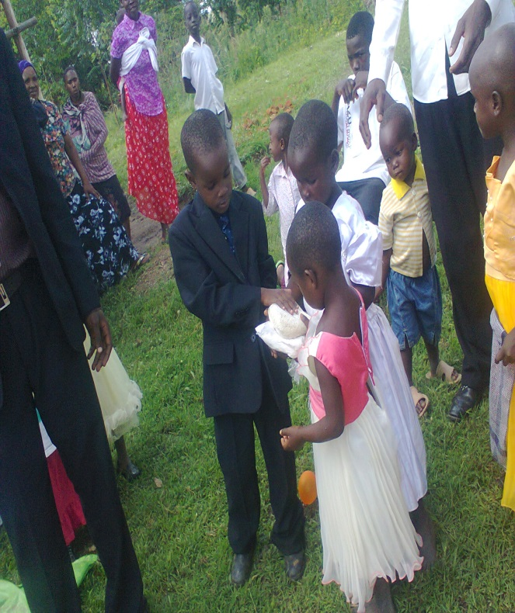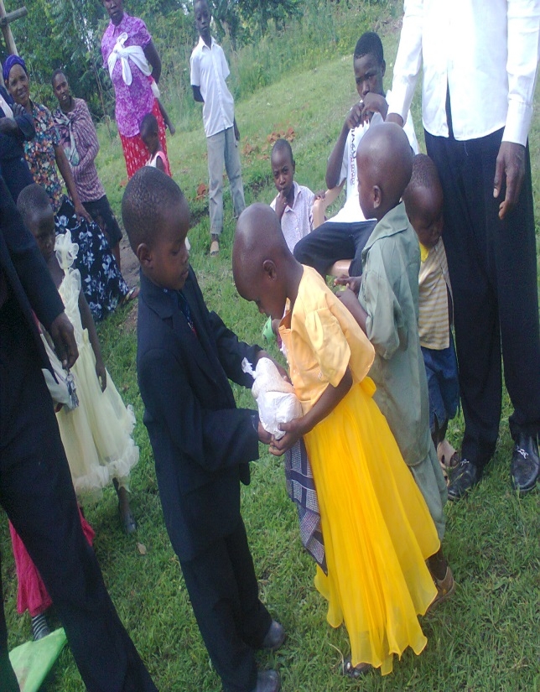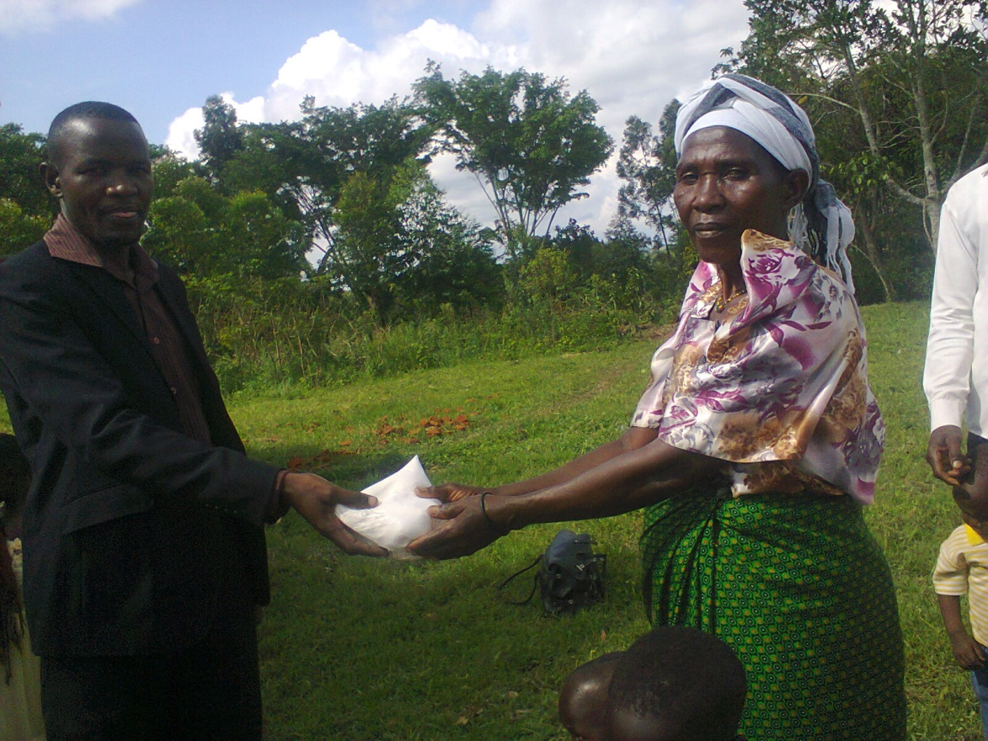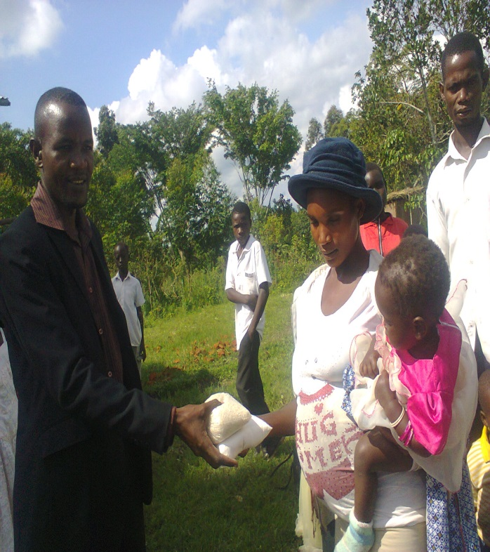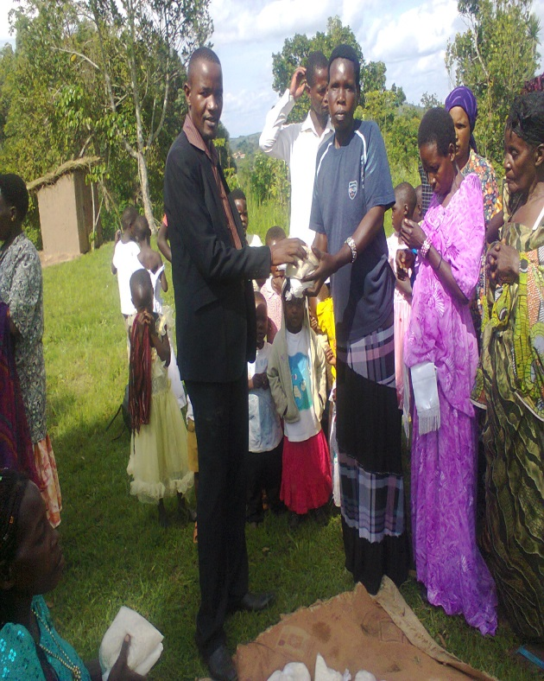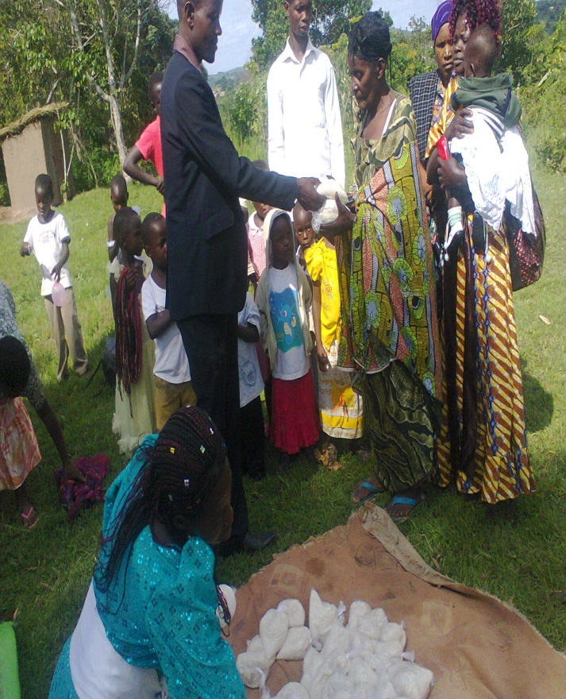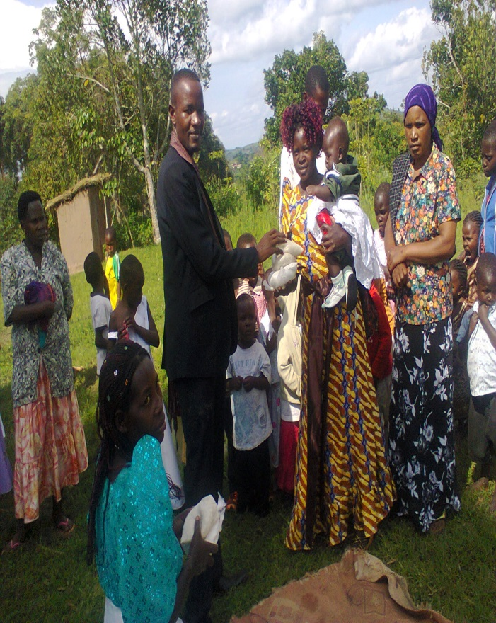
Above Pastor Dollar felling the rice and maize flour to church from the shops in city for the needy and elderly
Rice, maize flour and beans at church, before the give away
Sorting it out and putting them in polythene bags in Jesus name.
Sorting it out and putting them in polythene bags in Jesus name, Pst Davis there part of team, hands on.
Sorting it out and putting them in polythene bags in Jesus name.
Giving out the food to the needy children for them to have any Easter at home amen thanks brother for the kind heart and help
Teaching my son the works of the Father and one of them is take care of the needy, my son in blue suit giving out food to the young needy children too, wishing them a nice easter.
Reaching out to the needy Elderly in community with Easter food so they could have food in their houses for Easter, the mother on Left with hut appreciate so much that the Lord Jesus gave her some meal on this day the her child didn’t go hungry and herself.

I would like to thank you once again for the kind help you have offered to this day and made these 100 people have a meal in their houses and provide also 400 plates of food in their homes, Jesus bless you Much.
Your brother and fellow servant of the Lord
PASTOR SSENDIKWANAWA DAVIS DOLLAR
MWERA MIRACLE CENTER
P.O BOX 1680 KAMPALA, UGANDA EAST AFRICA
davislove123@gmail.com /
www.facebook.com/Mircalechildhopepeoject
+256752896993
ww.mweramiraclecentre.yolasite.com

